ISO WD 23247-2:2019(E)_v0.3
ISO TC 184/SC 4/WG 15
Secretariat: ANSI
Automation systems and integration — Digital Twin manufacturing framework — Part 2: Reference architecture

WD stage

Warning for WDs and CDs
This document is not an ISO International Standard. It is distributed for review and comment. It is subject to change without notice and may not be referred to as an International Standard.
Recipients of this draft are invited to submit, with their comments, notification of any relevant patent rights of which they are aware and to provide supporting documentation.

© ISO 2019, Published in Switzerland
All rights reserved. Unless otherwise specified, no part of this publication may be reproduced or utilized otherwise in any form or by any means, electronic or mechanical, including photocopying, or posting on the internet or an intranet, without prior written permission. Permission can be requested from either ISO at the address below or ISO’s member body in the country of the requester.
ISO copyright office
Ch. de Blandonnet 8 • CP 401
CH-1214 Vernier, Geneva, Switzerland
Tel. + 41 22 749 01 11
Fax + 41 22 749 09 47
copyright@iso.org
www.iso.org
Contents
Foreword v
Introduction vi
1 Scope 1
2 Normative references 1
3 Terms and definitions 1
4 Abbreviated terms 2
5 Digital Twin Reference Architecture (RA) goals and objectives 3
6 Requirements of Digital Twin 4
6.1 Information modeling 4
6.1.1 Fidelity 4
6.1.2 Extensibility 4
6.1.3 Interoperability 4
6.1.4 Scalability 4
6.2 In the loop simulation 4
6.2.1 Software-in-the-loop (SIL) simulation 4
6.2.2 Hardware-in-the-loop (HIL) simulation 4
6.3 Information exchange 4
6.3.1 Timely-manner networking 4
6.3.2 Synchronization 4
6.3.3 Accuracy 4
6.3.4 Integrity 4
6.4 Identification of information objects 5
6.4.1 Uniqueness 5
6.4.2 Associated information objects 5
7 Digital Twin RM 6
7.1 General 6
7.2 Entity-based RM 6
7.2.1 Entities of Digital Twin system 6
7.2.2 Physical Manufacturing Element Entity (PMEE) 6
7.2.3 Data Collecting & Controlling Device Entity (DCCDE) 7
7.2.4 Operation & Management Sub-system Entity (OMSE) 7
7.2.5 Application & Service Sub-system Entity (ASSE) 7
7.2.6 Resource Access & Interchange Sub-system Entity (RAISE) 7
7.2.7 Digital Twin User Entity (DTUE) 7
7.2.8 Network Entity (NE) 7
7.3 Domain-based RM 8
7.3.1 Domains of Digital Twin system 8
7.3.2 Physical Manufacturing Element Domain (PMED) 8
7.3.3 Data Collecting & Controlling Domain (DCCD) 8
7.3.4 Operation & Management Domain (OMD) 8
7.3.5 Application & Service Domain (ASD) 8
7.3.6 Resource Access & Interchange Domain (RAID) 8
7.3.7 User Domain (UD) 8
7.4 Relationship of entity based and domain based RM 9
8 Digital Twin Reference Architectural (RA) views 10
8.1 General 10
8.2 Functional view 10
8.2.1 Functional Reference Architecture view 10
8.2.2 Functional Entity (FE) in PHEE 10
8.2.3 Functional Entity in DCCDE 10
8.2.4 Functional Entity in OMSE 11
8.2.5 Functional Entity in ASSE 11
8.2.6 Functional Entity in RAISE 12
8.2.7 Functional Entity in DTUE 12
8.2.8 Functional Entity in Cross-Entity 12
8.3 Networking view 13
8.3.1 Networking Reference Architecture view 13
8.3.2 Proximity Network 13
8.3.3 Access Network 13
8.3.4 Service Network 13
8.3.5 User Network 13
Annex A (informative) Annex title 14
A.1 TBD 14
A.1.1 TBD 14
A.1.1.1 TBD 14
Bibliography 15

Foreword
ISO (the International Organization for Standardization) is a worldwide federation of national standards bodies (ISO member bodies). The work of preparing International Standards is normally carried out through ISO technical committees. Each member body interested in a subject for which a technical committee has been established has the right to be represented on that committee. International organizations, governmental and non-governmental, in liaison with ISO, also take part in the work. ISO collaborates closely with the International Electrotechnical Commission (IEC) on all matters of electrotechnical standardization.
The procedures used to develop this document and those intended for its further maintenance are described in the ISO/IEC Directives, Part 1. In particular the different approval criteria needed for the different types of ISO documents should be noted. This document was drafted in accordance with the editorial rules of the ISO/IEC Directives, Part 2 (see www.iso.org/directives).
Attention is drawn to the possibility that some of the elements of this document may be the subject of patent rights. ISO shall not be held responsible for identifying any or all such patent rights. Details of any patent rights identified during the development of the document will be in the Introduction and/or on the ISO list of patent declarations received (see www.iso.org/patents).
Any trade name used in this document is information given for the convenience of users and does not constitute an endorsement.
For an explanation on the voluntary nature of standards, the meaning of ISO specific terms and expressions related to conformity assessment, as well as information about ISO's adherence to the World Trade Organization (WTO) principles in the Technical Barriers to Trade (TBT) see the following URL: www.iso.org/iso/foreword.html.
This document was prepared by Technical Committee ISO/TC 184, [Automation systems and integration], Subcommittee SC 4, [Industrial Data].
A list of all parts in the ISO 23247 series can be found on the ISO website.

Introduction
Digital Twin is a virtual representation of manufacturing elements such as personnel, products, assets and process definitions. Digital Twin is a living model that continuously updates and changes as the physical counterpart changes to represent status, working conditions, product geometries and resource states in a synchronous manner.
Digital Twin representations of the products and physical resources are utilized to detect anomalies in the manufacturing processes. The digital representation provides information on the physical manufacturing elements to define the dynamic behavior of the manufacturing process and results. It is an understanding of the characteristics and capabilities of these elements and how they operate and respond throughout the production lifecycle. The digital representation constantly communicates with the physical manufacturing resources through exchange of operational and environmental data.
This digital representation is utilized to achieve various functional objectives such as synchronous monitoring/alarm, manufacturing operations management (MOM) optimization, in-process adaptation, big data analytics and machine learning. The visibility into manufacturing process definition and execution enabled by Digital Twinning enhances business cooperation and multiple efficiencies.

Automation systems and integration — Digital Twin manufacturing framework — Part 2: Reference architecture

Scope
A family of ISO 23247 standards defines a framework for Digital Twin manufacturing as virtual representations of physical manufacturing elements such as personnel, products, assets and process definitions. This document provides
- requirements for Digital Twin manufacturing realization in terms of information modelling, in-the-loop simulation, information exchange, and identification of information objects, and;
- reference architecture

Normative references
The following documents are referred to in the text in such a way that some or all of their content constitutes requirements of this document. For dated references, only the edition cited applies. For undated references, the latest edition of the referenced document (including any amendments) applies.
ISO/IEC 30141, Internet of Things (IoT) — Reference architecture

Terms and definitions
For the purposes of this document, the following terms and definitions apply.
ISO and IEC maintain terminological databases for use in standardization at the following addresses:
— IEC Electropedia: available at http://www.electropedia.org/
— ISO Online browsing platform: available at https://www.iso.org/obp
3.1
Digital Twin
to be imported from ISO 23247-1
[SOURCE: ISO 23247-1, 3.x]

3.1
Digital Twin system
set of physical manufacturing entities, data collecting and controlling entities, Digital Twin (consisting of operation and management sub-system entity, application and service sub-system entity, and resource access and interchange sub-system), digital twin user entity, and network entity
3.2
digital object
digitally represented object of a physical object
3.3
physical object
physical manufacturing resources to be digitally represented such as personnel, equipment, material, and process segment

Abbreviated terms
ASD application and service domain
ASSE application and service sub-system entity
DCCD data collecting and controlling domain
DCCDE data collecting and controlling device entity
DTUE Digital Twin user entity
FE functional entity
HIL hardware-in-the-loop
IoT Internet of Things
OMD operation and management domain
OMSE operation and management sub-system entity
PHED physical manufacturing elements domain
PMEE physical manufacturing element entity
RA reference architecture
RAID resource access and interchange domain
RAISE resource access and interchange sub-system entity
RM reference model
SIL software-in-the-loop
UD user domain

Digital Twin Reference Architecture (RA) goals and objectives
Digital Twin reference architecture (RA) defines requirements of Digital Twin, a reference model (RM) and several of architectural views.
Digital Twin RA outlines what the overall structured approach for the construction of Digital Twin should be by providing reference architecture. In other words, Digital Twin provides guidance for the architect developing Digital Twin and aims to give a better understanding of Digital Twin to the stakeholders of such systems, including device manufacturers, application developers, customers and users.
This document has the following descriptions:
- requirements of Digital Twin in terms of information modelling, in-loop simulation, information exchange and identification of information objects;
- a Digital Twin RM, providing the overall structure of the elements of Digital Twin RA;
- a set of relevant architectural views, describing the architecture from a number of perspectives

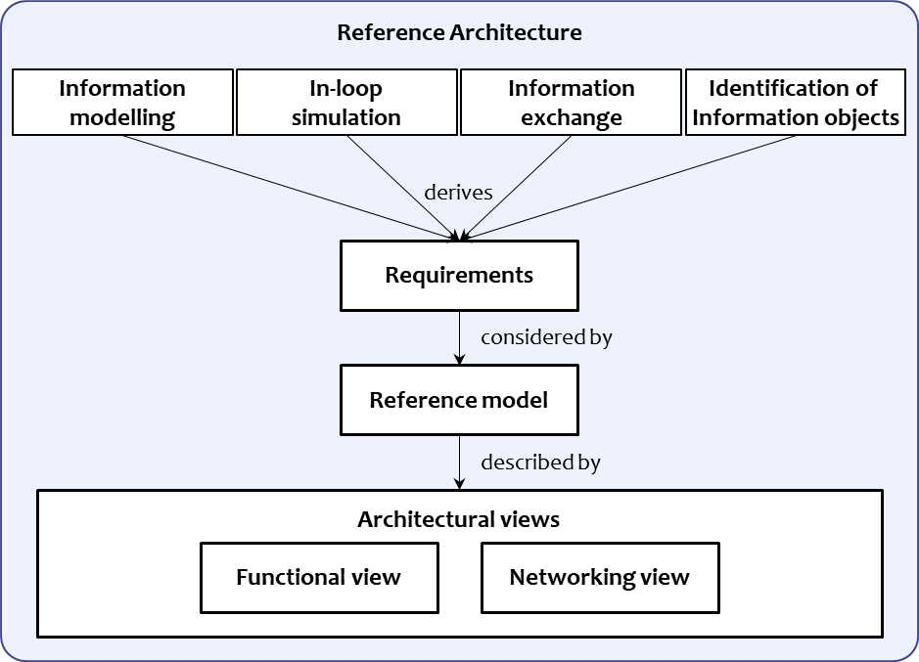
Figure 1 – Digital Twin RA structure
Figure 1 shows how Digital Twin RA is derived from requirements that define a Digital Twin RM and one or more architectural views.

Requirements of Digital Twin

Information modeling

Fidelity
Ability to describe the closeness to the physical product

Extensibility
Ability to integrate, to add, or to replace models

Interoperability
Ability to convert, to combine, and to establish equivalence between different model representations

Scalability
Ability to provide an insight at different scales (from fine details to large systems)

In the loop simulation

Software-in-the-loop (SIL) simulation
Ability to integrate manufacturing software into a mathematical model simulation based on running manufacturing system

Hardware-in-the-loop (HIL) simulation
Ability to integrate manufacturing hardware into a mathematical model simulation based on running manufacturing system

Information exchange

Timely-manner networking
Ability to exchange information within a given time using an appropriate networking protocol

Synchronization
Ability to synchronize the status of the digital object with the status of the physical object or vice versa, using timely-manner networking

Accuracy
Ability to keep data accurate to be exchanged

Integrity
Ability to maintain data unchanged in exchanging procedures

Identification of information objects

Uniqueness
Ability to identify an information object uniquely and unambiguously

Associated information objects
Ability to identify an association of an information object with other information objects

Digital Twin RM

General
Digital Twin encompasses Internet of Things (IoT) as its data colleting and controlling technology as well as conceptual background.
ISO/IEC 30141 defines IoT RM including entity-based RM and domain-based RM, and also defines RA by providing several reference architectural views including functional view, system deployment view, networking view, and usage view. By the properties of Digital Twin based on IoT, this document defines Digital Twin RM based on IoT RM.

Entity-based RM

Entities of Digital Twin system
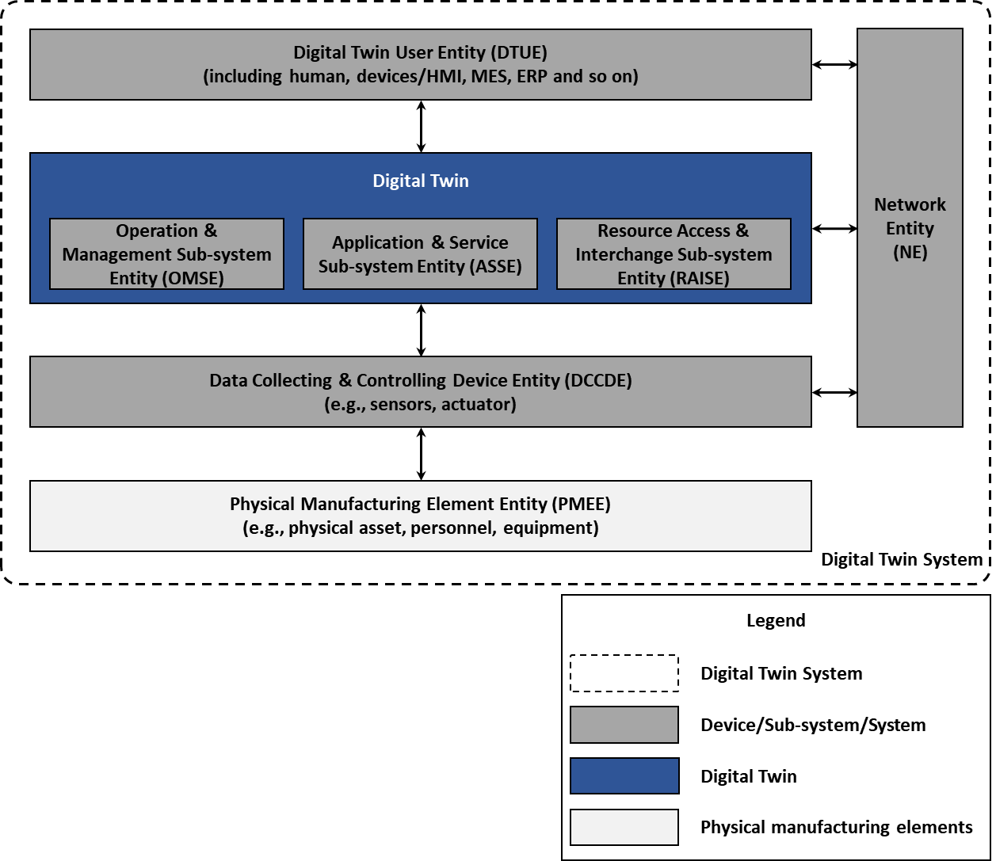
Figure 2 – Entity-based Digital Twin Reference Model

Physical Manufacturing Element Entity (PMEE)
to be explained

Data Collecting & Controlling Device Entity (DCCDE)
to be explained

Operation & Management Sub-system Entity (OMSE)
to be explained

Application & Service Sub-system Entity (ASSE)
to be explained

Resource Access & Interchange Sub-system Entity (RAISE)
to be explained

Digital Twin User Entity (DTUE)
to be explained

Network Entity (NE)
to be explained

Domain-based RM

Domains of Digital Twin system
[Project leader’s note] The domains help the designer to focus on the various tasks that have to be performed, by allowing a logical (and sometimes physical) subdivision. Mainly, domains are used to sort functions in areas of responsibility. (ISO/IEC 30141)
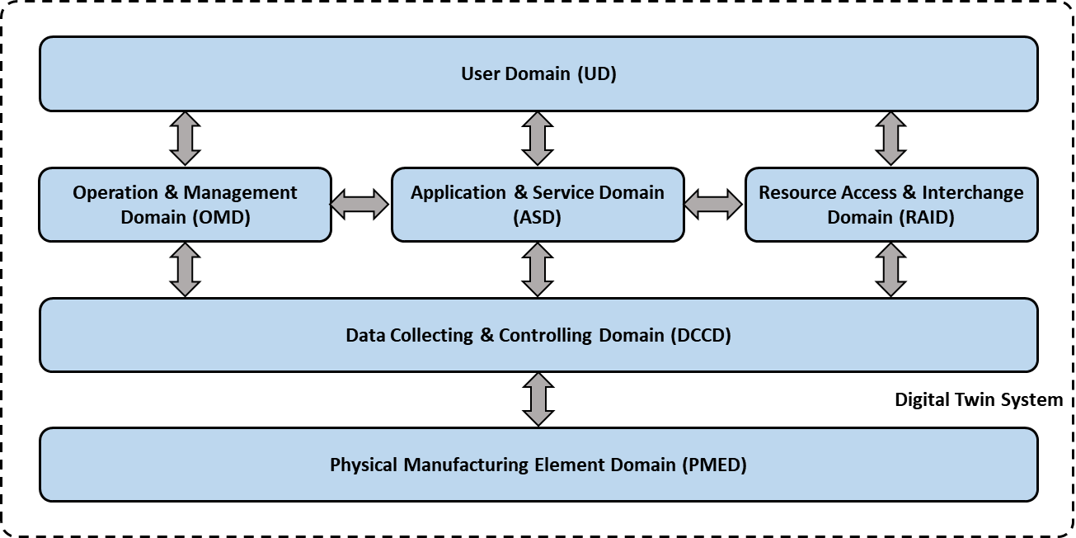
Figure 3 – Domain-based Digital Twin Reference Model

Physical Manufacturing Element Domain (PMED)
to be explained

Data Collecting & Controlling Domain (DCCD)
to be explained

Operation & Management Domain (OMD)
to be explained

Application & Service Domain (ASD)
to be explained

Resource Access & Interchange Domain (RAID)
to be explained

User Domain (UD)
to be explained

Relationship of entity based and domain based RM
to be explained
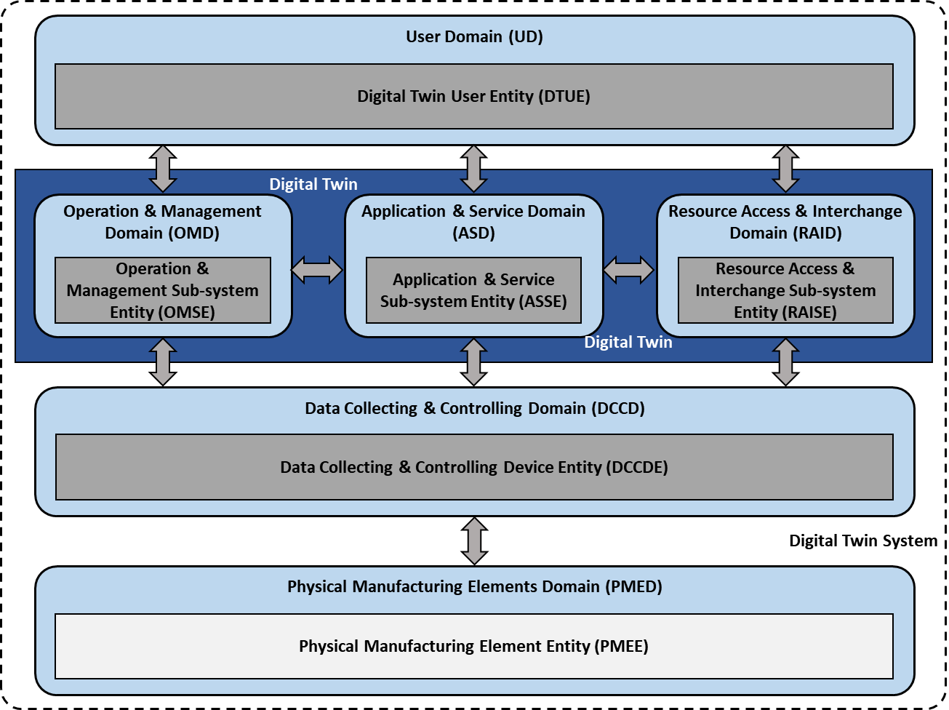
Figure 4 – Relationship of entity-based Digital Twin RM and domain-based Digital Twin RM

Digital Twin Reference Architectural (RA) views

General
As explained in 7.1, this document defines Digital Twin functional view and networking view based on IoT RA defined by ISO/IEC 30141.

Functional view

Functional Reference Architecture view
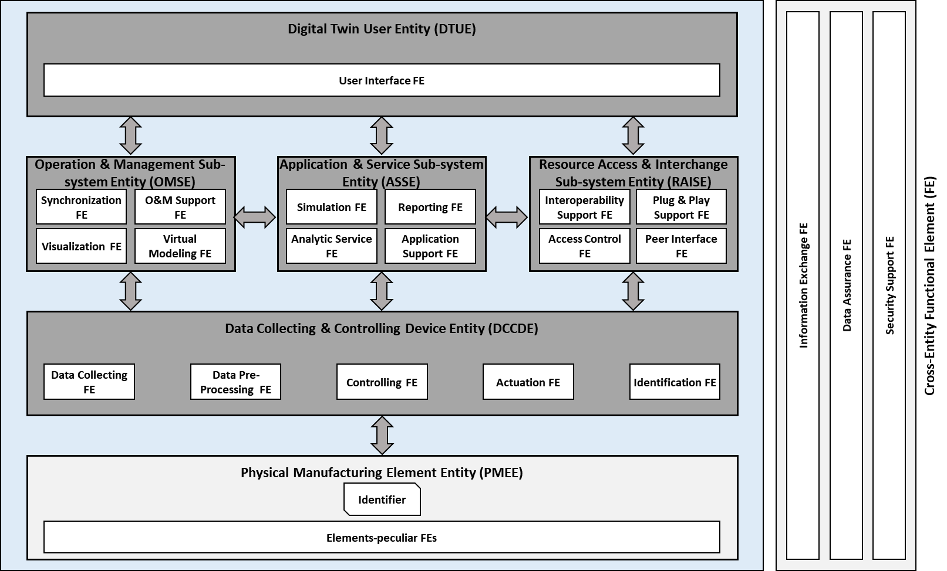
Figure 5 – Functional view of Digital Twin reference architecture –
decomposition into functional entities (FE)

Functional Entity (FE) in PHEE

Element-peculiar FE
This FE is physical manufacturing element specific functional entities, therefore various functions can be supported by this FE according to its capabilities. This FE is out of scope of this document.

Functional Entity in DCCDE

Data Collecting FE
Data collecting FE provides data collection functionality from PMEE.

Data Pre-Processing FE
Data pre-processing FE provides pre-processing functionality for collected data, for example filtering and aggregation.

Controlling FE
Controlling FE provides functionality of controlling PMEE by the request from Digital Twin system.

Actuation FE
Actuation FE provides functionality of actuating PMEE by the request from Digital Twin system, similarly with controlling FE.

Identification FE
Identification FE provides functionality of identifying PMEE and its data to be collected uniquely and unambiguously.

Functional Entity in OMSE

Synchronization FE
Synchronization FE provides functionality of synchronizing the status of the visualized digital object with the status of the physical object, or vice versa.

Visualization FE
Visualization FE provides functionality of visualizing a physical object as a digital object in conjunction with virtual modeling FE.

Virtual Modeling FE
Virtual modeling FE provides functionality of interpreting information model of a physical object to understand its physical properties, status, and so on.

O&M Support FE
O&M support FE provides functionalities of operating and managing a Digital Twin system.

Functional Entity in ASSE

Simulation FE
Simulation FE provides functionalities of in-the-loop simulation including SIL simulation and HIL simulation.

Analytic Service FE
Analytic service FE provides functionality of analysing data collected from PMEE and the result of simulation.

Reporting FE
Reporting FE provides functionality of generating report of production result, analysis on simulation, and so on.

Application Support FE
Application support FE provides functionality of hosting platform for implementing predictive and reactive, open and closed loop applications (e.g., Node.js).

Functional Entity in RAISE

Interoperability Support FE
Interoperability support FE provides functionality of interworking with other Digital Twin systems in conjunction with peer interface FE.

Access Control FE
Access control FE provides functionality of controlling DTUE’s access to PMEE in conjunction with security support FE.

Plug & Play Support FE
Plug & play support FE provides functionality of dynamic involvement of PMEE, i.e., joining and leaving Digital Twin system, in run time.

Peer Interface FE
Peer interface FE provides functionality of interfacing to other Digital Twin systems in conjunction with interoperability support FE.

Functional Entity in DTUE

User Interface FE
User interface FE provides DTUE with functionality of interfacing to Digital Twin.

Functional Entity in Cross-Entity

Information Exchange FE
Information exchange FE provides functionality of exchanging information among entities of Digital Twin system by appropriate networking protocols.

Data Assurance FE
Data assurance FE provides accuracy and integrity of data in conjunction with security support FE.

Security Support FE
Security support FE provides functionality of securing Digital Twin system including authentication, authorization, confidentiality, integrity, and so on.

Networking view

Networking Reference Architecture view
to be explained (examples are needed)
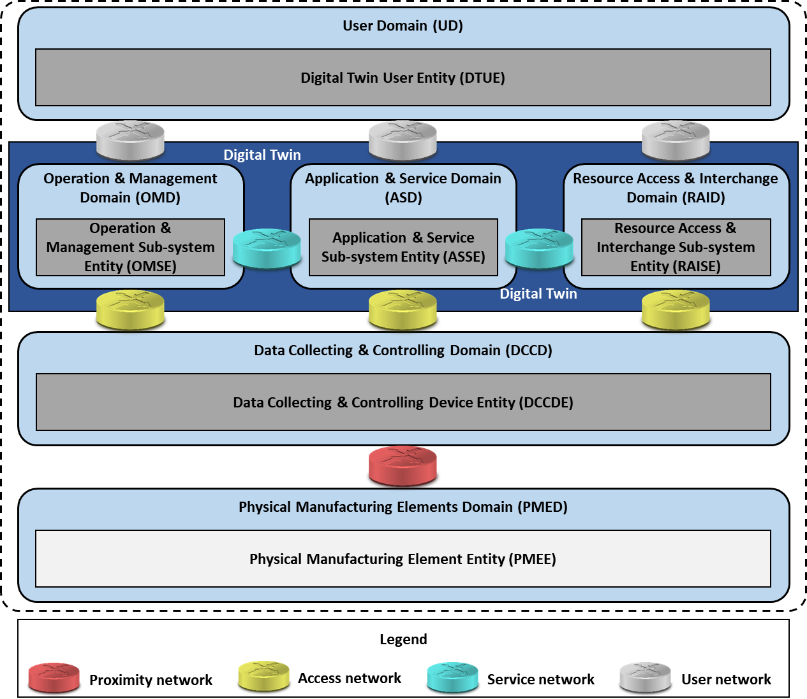
Figure 6 – Networking view of Digital Twin reference architecture

Proximity Network
to be explained
NOTE: example Wireless Sensor Network, 5G, IoT, MTconnect??? Dedicated use only?

Access Network
to be explained

Service Network
to be explained

User Network
to be explained
- (informative)
Annex title
  - TBD
    - TBD
      - TBD

Bibliography
[1] Benjamin Schleich, Nabil Anwer, Luc Mathieu and Sandro Wartzack, Shaping the digital twin for design and production engineering, CIRP Annals, 2017
[2] TBA ISO #####-##:20##, General title — Part ##: Title of part

