Outline for NWIP ISO xxxxx - series

Proposal of new work items on
Digital twin manufacturing framework

- Overview of digital twin manufacturing
The digital twin in manufacturing is a virtual representation of the physical model of asset, process, system, or service by collecting data from manufacturing, maintenance, operations, and operating environments (See Appendix I). The digital twin is a living model that continuously updates and changes as their counterpart changes to represent near real-time status, working condition or position.
To realize digital twin in manufacturing, digital representation of the resources are to be made to detect anomalies in the manufacturing resources. The digital representation provides information of the resources (i.e., personnel, equipment, physical asset, material, process segment, etc.) and the dynamic behaviors of the resources. It is an understanding of the characteristics and capabilities of the resources and how the resources operate and respond throughout production lifecycle. The digital representation constantly communicates with the manufacturing resources through exchange of operational and environmental data. The digital twin can be used for systematic identification, optimize operation, near-accurate monitoring, adapt to changes, etc.

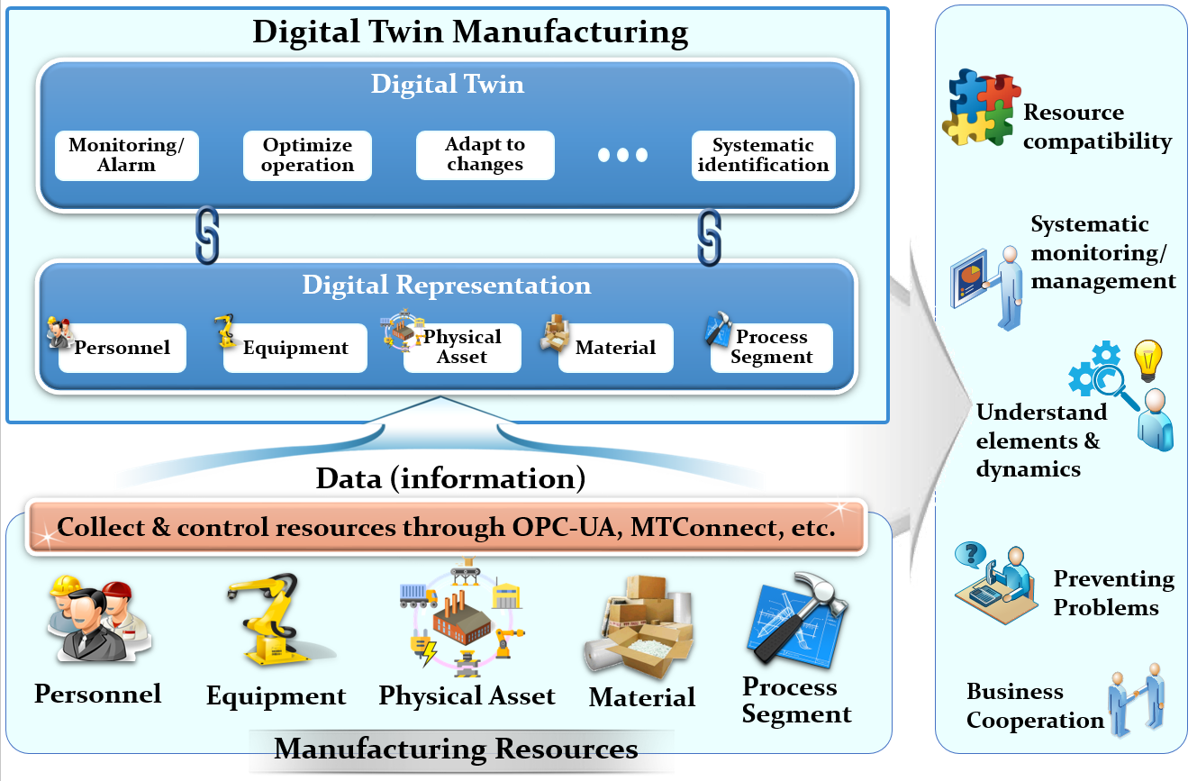
Figure 1 – Digital twin manufacturing

Through digital twin manufacturing, it is possible to understand the utilization and dynamics of the resources, analysis of data and monitoring of systems, prevent problems before they even occur, prevent downtime, enhance business cooperation, and room for many more new opportunities.
The description and data for dynamic modeling of manufacturing resources are followings.
- personnel: the personnel involved in manufacturing operations management [IEC 62264-1]. Some dynamic modeling aspects to consider are temporary/permanent worker, availability, schedule, leadership, skills, emotional status, training, experiences, etc.
- equipment: the equipment (role-based and physical asset) involved in manufacturing operations management [IEC 62264-1]. Some dynamic modeling aspects to consider are equipment manufacturer, progress status, schedule, performance parameter, operating technique, training/skills needed, etc.
- material: the material involved in manufacturing operations management [IEC 62264-1]. Some dynamic modeling aspects to consider are quality, quantity, expiration date, storage and handling method, safety measures, etc.
- process segment: an identification of personnel, equipment, physical assets, and material resources with specific capabilities needed for a segment of production, independent of any particular product at the level of detail required to support business processes that may also be independent of any particular product [IEC 62264-1]. Some dynamic modeling aspects to consider are instruction, specification, supervisory framework, testing, tolerance, etc.

- Gap analysis of other standards
2.1 Gap with IEC 62264
According to IEC 62264-1, the resource is defined as “enterprise entity that provides some or all of the capabilities required by the execution of an enterprise activity and/or business process.”
The resources defined in IEC 62264 are personnel, equipment, physical assets, and material. IEC 62264-2 has modelled these resources in terms of resource capability, resource capability property, resource category definition, resource category property, resource definition, and resource property. It defines method on how to express the characteristics and capabilities of the resources.
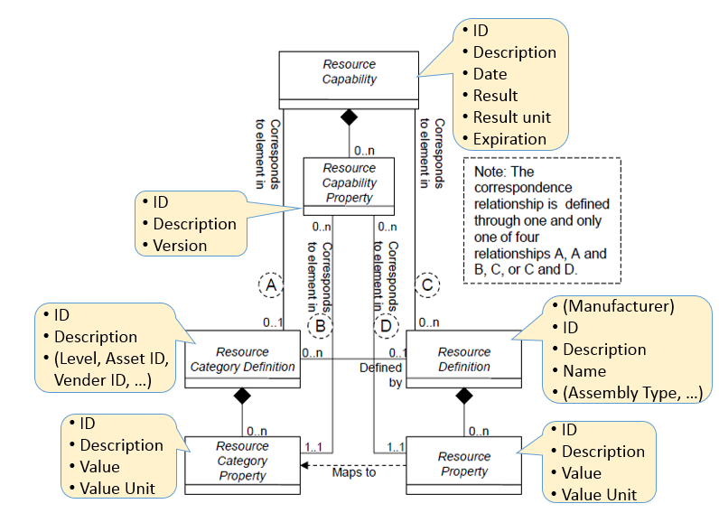
Figure 2 – Resource defined in IEC 62264-2

The scope of IEC 62264-2 is limited to the definition of objects and attributes of manufacturing resources in the Level 3 manufacturing systems in the hierarchical model defined in IEC 62264-1. IEC 62264-2 standard does not define attributes to represent the object relationships, and does not consider the virtual representation of the resources and activities.
The gaps of IEC 62264-2 and this new proposal are summarized as follows;
- IEC 62264-2 specifies objects and attributes exchanged between manufacturing control functions and other enterprise functions, and defines a set of elements contained in the generic interface, together with a mechanism for extending those elements for implementations, whereas,
- this proposal provides the digital representation of the resources, relationships among resources, and their status changes (existence, physical status change, and availability, etc.) during manufacturing processes.

2.2 Gap with IEC 62832
Several ISO and IEC standards such as IEC 61987 series, IEC 61360-1 and 2, ISO 13584-42 and ISO 22745 provide a method for describing properties of a given device. IEC 62832 extends this method by defining a reference model for the digital representation of production systems, which include the devices.
IEC 62832 defines a framework used for establishing and maintaining the digital representation of production systems throughout its life cycle, including the elements, relationship between these elements, and the exchange of information about these elements. This digital representation provides a consistent information interchange between all processes and partners involved and makes related information understandable, reusable, and changeable through the entire production system life cycle.
However, IEC 62832 does not cover input resources (such as raw production material, assembly parts), consumables, and work pieces in process which this proposal aims for.
The gaps of IEC 62832 and this new proposal are summarized as follows;
- IEC 62832 provides the digital representation of production systems in focus of digital representation of devices and its association and relation information with other devices throughout the production system life cycle, whereas,
- this proposal provides the digital representation of manufacturing resources including personnel, material and process segment as well as devices (called equipment in this document) which are involved in work in process for digital twin manufacturing.

- Proposal of new work items
Based on the findings from the previous clauses, it is necessary to start new works on digital twin manufacturing framework.
The purpose of the new work is to support digital twin manufacturing in terms of digital representation of manufacturing resources including modeling of physical configuration and dynamic changes.
Followings are proposed prospective parts and scopes of digital twin manufacturing framework standards;
- Part 1: Overview and general principles
Provide overview of digital twin manufacturing and describe general principles for digital twinning to give a guidance for digital twin manufacturing framework standardization,
- Part 2: Framework
Provide architectural framework, set of terms and definitions, and requirements for digital twin manufacturing realization in terms of information modeling, hardware-in-the-loop simulation, information exchange, identification of information objects, etc.,
- Part 3: Digital representation of manufacturing resources
Classify manufacturing resources (including characteristics) and create digital representation of manufacturing resources for information model and manufacturing resource identification,
- Part 4: Information exchange of digital twin manufacturing
Define technologies such as network protocol, APIs, description languages, etc., required for information exchange and management of digitally represented manufacturing resource.

Bibliography

- Wikipedia, “Digital twin”, https://en.wikipedia.org/wiki/Digital_twin, accessed in Nov. 01, 2017
- Forbes, “What Is Digital Twin Technology - And Why Is It So Important?”, https://www.forbes.com/sites/bernardmarr/2017/03/06/what-is-digital-twin-technology-and-why-is-it-so-important/#617c3ec02e2a, accessed in Nov. 01, 2017
- Infosys, “The Future for industrial services: the digital twin”, https://www.infosys.com/insights/services-being-digital/Documents/future-industrial-digital.pdf, accessed in Nov. 01, 2017
- IBM Watson, “Introduction to Digital Twin: Simple, but detailed”, https://www.youtube.com/watch?v=RaOejcczPas, accessed in Nov. 01, 2017
- IEC 62264-1 Edition 2.0: Enterprise-control system integration – Part 1: Models and terminology (2013)
- IEC 62264-2 Edition 2.0: Enterprise-control system integration – Part 2: Object model attributes (2013)
- IEC 62264-3 Edition 2.0: Enterprise-control system integration – Part 3: Activity models of manufacturing operations management (2016)
- IEC 62264-4 Edition 2.0: Enterprise-control system integration – Part 4: Objects models attributes for manufacturing operations management integration (2015)
- IEC TS 62832-1, Industrial-process measurement, control and automation – Digital Factory framework – Part 1: General principles (2016)

Appendix I
Definition of digital twin in various sources

Source (Wikipedia): digital twin refers to a digital replica of physical assets, processes and systems. The digital representation provides both the elements and the dynamics of how an Internet of Things device operates and lives throughout its life cycle.
Digital Twins integrate artificial intelligence, machine learning and software analytics with data to create living digital simulation models that update and change as their physical counterparts change. A digital twin continuously learns and updates itself from multiple sources to represent its near real-time status, working condition or position. This learning system, learns from itself, using sensor data that conveys various aspects of its operating condition; from human experts, such as engineers with deep and relevant industry domain knowledge; from other similar machines; from other similar fleets of machines; and from the larger systems and environment in which it may be a part of. A digital twin also integrates historical data from past machine usage to factor into its digital model.
In various industrial sectors, twins are being used to optimize the operation and maintenance of physical assets, systems and manufacturing processes. They are a formative technology for the Industrial Internet of Things, where physical objects can live and interact with other machines and people virtually.
Ref) Wikipedia, “Digital twin”, https://en.wikipedia.org/wiki/Digital_twin, accessed in Nov. 01, 2017

Source (Forbes): digital twin is defined as a virtual model of a process, product or service. This pairing of the virtual and physical worlds allows analysis of data and monitoring of systems to head off problems before they even occur, prevent downtime, develop new opportunities and even plan for the future by using simulations.
First, smart components that use sensors to gather data about real-time status, working condition, or position are integrated with a physical item. The components are connected to a cloud-based system that receives and processes all the data the sensors monitor. This input is analyzed against business and other contextual data.
Lessons are learned and opportunities are uncovered within the virtual environment that can be applied to the physical world — ultimately to transform your business.
Ref) Forbes, “What Is Digital Twin Technology - And Why Is It So Important?”, https://www.forbes.com/sites/bernardmarr/2017/03/06/what-is-digital-twin-technology-and-why-is-it-so-important/#617c3ec02e2a, accessed in Nov. 01, 2017

Source (Infosys): The Digital Twin collects data from its manufacturing, maintenance, operations, and operating environments and uses this data to create a unique model of each specific asset, system, or process, while focusing on a key behaviour (such as life, efficiency, or flexibility). This is the ‘model of one.’
Analytics are then applied to these models to detect anomalies in the system. The twin then determines an optimal set of actions that maximize some key performance metrics, and provides forecasts for long-term planning.
The Digital Twin is then used in a specified analytics workflow to enable the delivery of a specific business outcome, using environmental and operational data that is consistently acquired. This consistent data flow permits the Digital Twin model to continually adapt to changes in the environment or operations and deliver the best business outcome.
The Digital Twin is essentially a living model of the physical asset or system, which will continually adapt to changes in the environment or operations and deliver the best business outcome. It can also be rapidly and easily scaled for quick deployment for other, similar applications.
Ref) Infosys, “The Future for industrial services: the digital twin”, https://www.infosys.com/insights/services-being-digital/Documents/future-industrial-digital.pdf, accessed in Nov. 01, 2017

Source (IBM Watson): Digital twin is the ability to make a virtual representation of the physical elements and the dynamics of how an Internet of Things device operates and works. It's more than a blueprint, it's more than a schematic. It's not just a picture. It's a lot more than a pair of ‘virtual reality’ glasses. It's a virtual representation of both the elements and the dynamics of how an Internet of Things device responds throughout its lifecycle. It is the understanding of the dynamics (electrons, device movement). It is understanding of the device is composed and dynamics of how that device is put together. It can be a jet engine, a building, process on factory floor, and much, much more.
Ref) IBM Watson, “Introduction to Digital Twin: Simple, but detailed”, https://www.youtube.com/watch?v=RaOejcczPas, accessed in Nov. 01, 2017

